In attendance: Diane Ackerman, Ned Panfile, Stephanie Fourie, Kevin Lanahan, Tim McChesney, Bruce DiBisceglie (dept chair), and James Fourie (junior student representative) Meeting held at the Garabrant Center.

- Communications
  - The July 15, 2021, Mendham Borough Recreation Committee (MBRC) meeting minutes were approved. Minutes will be posted to the Mendham Borough website.
  - Communications:
    - RSVPs for the Labor Day Parade
  - Meetings:
    - On July 26th Steve Andrew & Bruce attended the meeting of Mayor & Council.
      - Steve reported that Day Camp & Concerts has been well attended.
    - On August 23rd Steve Andrew & Bruce attended the meeting of Mayor & Council.
      - Steve reported that:
        - The Labor Day Parade is on September 6th.
        - The Food Truck & Music Festival is on October 2nd
      - Bruce reported that:
        - Ford/Audi does not have the convertible stock to offer to the 2021 Labor Day Parade
        - As a result of a community Nixle message & eBlast, six residents have offered convertibles for the parade.

- Labor Day Preparation/Assignments
  - Bruce will coordinate the Parade from the Heritage Manor, East Main a Tempe Wick confluence. He will be assisted by Jim Devine and the Knights of Columbus. Bruce will manage line-up on Heritage Manor with dignitaries. The Knights will assist lining up on East Main.
  - Kevin will announce from the Phoenix House
  - Bob Diffin will announce from the gazebo.
  - Stephanie will assist lining up on Tempe Wick.
  - Ned will manage the high school participants from the HS parking lot.
  - Forty-six confirmation RSVPs have been received from: Boy Scouts Troop 1 Color Guard, Cub Scouts Troop 133, Mendham Area Girl Scouts Troop 6, Chief Camoia / Father Mike, Grand Marshall - Richard Kraft, Mayor and Council, Senator Tony Bucco Jr, Assemblywoman Aura Dunn, Morris County / Mendham Democrats, Mendham Township Republicans, Rory O'Moore Pipe Band, Mendham Borough First Aid Squad / EMT, Harvest Hustle, Mendham Day Camp, Denville String Band, Twin Boro Bears Cheerleaders, Twin Boro Bears Football, Backer Farms, George Connally Corvette, Mendham High School Band, Mendham HS Football Team, High School Varsity and JV Cheerleaders, Mendham Creamery, Shore Brass Band, Mendham Township Fire Dept (Brookside & Ralston), West Morris Soccer Club, Ralston Historical Association, Hilltop Presbyterian Church & Nursery School, Slattery Irish Dancers, Emerald Pipe Band, Chester Fire Dept & First Aid, Mendham Rotary Club, St. Colmcille Pipe Band, Mendham Magic Track and Field & Cross Country, Mendham Chester Patriots Wrestling, Grace Lutheran Church, Bloomingdale Cornet, Rob Trout & The Flounders. Alstead Farms, Mendham Plywood, Doug's Flower Market, Funny Factory Band, Knights of Columbus & The Altman Brothers
  - RSVPs are pending: Former Mayors, Morris County Commissioners (Stephen Shaw, Doug Cabana, Kathy DeFillippo, John Krickus, Tayfun Selen, Thomas Mastrangelo), Morris County Surrogate - Heather Darling, Morris County Sheriff - James Gannon, Morris County Clerk - Ann Grossi, Mendham Township Mayor & Council, Mendham Borough Board of Education, Mendham Borough Fire Department, 1940 Buick Special, Stable LTD, St Mark's Episcopal Church, Chester/Mendham Lacrosse, Randolph Fire Dept & Rescue Squad, Bernardsville Fire Dept & First Aid Squad, West Morris Youth Ice Hockey Club, Fairmount Fire Company (Long Valley), Weichert Realtors, Row New Jersey & Big Dog Rescue Project

- Concerts/Movie Wrap-Up
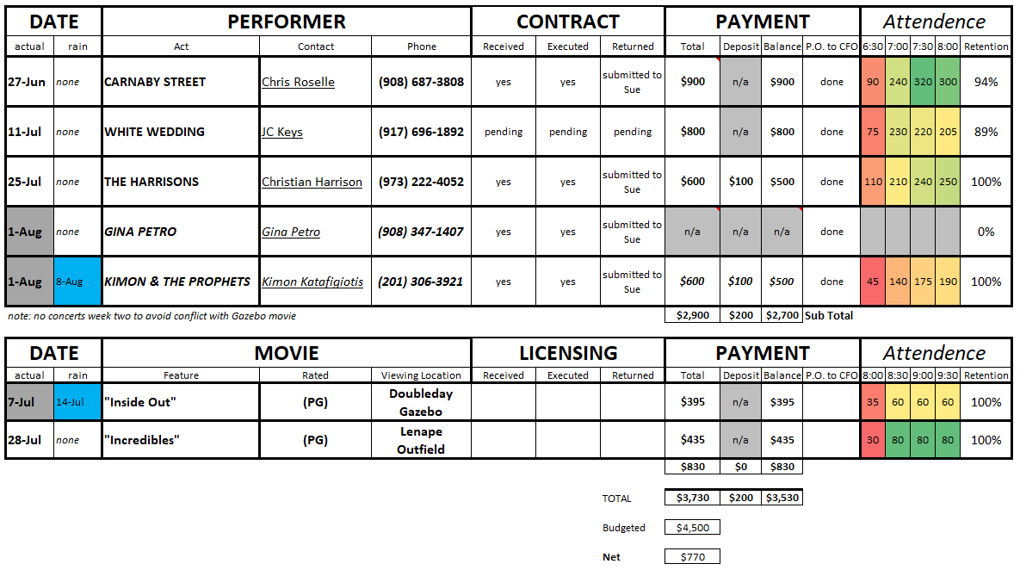
  - Despite low movie turn-out, the MBRC decided that movie events are still needed and will continue.

- Facility Update
  - Yoga in the Park has been a success.
  - The MBRC commented that DPW did a great job with the new park benches.

- Prior Business:
  - DPW quoted Peter Parrinello approx. $1,000 per backboard set up for new plexiglass backboards for courts.
  - Mendham Borough received the $800 Municipal Alliance Grant funds on July 19.

- New Business:
  - A complaint surfaced about someone marking up new tennis courts with pickleball lining.
    - Bruce has told all that inquired that tennis court are not to be altered for pickleball.
    - Ned reminded the MBRC that other communities with pickleball are having problems with noise complaints from pickleball games.
      - https://projects.nj.com/pickleball/
      - Research claims that pickleball sound levels within 100 feet of courts will usually be around 70dBs with no sound reduction efforts applied. This is as loud as freeway traffic sound.
    - MBRC recommends exploring pickleball at Pastime Field.
  - A suggestion was made to explore a conversion of the unused “t-ball” area of Borough Park to a simple water splash park surface.
    - One suggestion was to see if this can be used as an ice-skating area in the winter.

Next Meeting: 7:30 pm, Thursday, September 16th, 2021, Garabrant Center.

